

**“ONLINE TEST APPLICATION”**

Programming Paradigm-CS433

Submitted by:

**Anshu-1960411**

**B.M.Kavyashree-1960412**

**Dhwani Apurva Nagoree-1960416**

**Helen Mary Varghese-1960421**

**Excellence & Service**

To fortify Ethical Computational Excellence

**ABSTRACT**

Multiple Choice Questions or MCQs as we commonly call, comprises a question with multiple alternatives from which one is the answer. Nowadays, mcqs have a use in various fields like for competitive examinations, feedback forms, etc as it can be taken online. Since it is popularly used, we have created a Java program using various tools to create mcq.

**REQUIREMENTS**

Java application using GUI

**WORKING DESCRIPTION**

Online Test App project could be a web portal which is developed or implemented in java domain or platform. This project is helpful for students to practice different mock examinations from this site.AWT and Swing are used to develop window-based applications in Java. Awt is an abstract window toolkit that provides various component classes like Label, Button, TextField, etc., to show window components on the screen. All these classes are part of Java.

We are using method set and creating radiobutton of 4 to display 4 buttons of options and setting 10 questions with 4 options and we setting bounds for label and radiobutton and setting boolean check to check the right answers and finally including main method.

We are using method set and creating radiobutton of 4 to display 4 buttons of options and setting 10 questions with 4 options and we setting bounds for label and radiobutton and setting boolean check to check the right answers and finally including main method.

**SOURCE CODE**

import java.awt.event.ActionListener;

import java.awt.*;

import javax.swing.ButtonGroup;

import javax.swing.JButton;

import javax.swing.JFrame;

import javax.swing.JLabel;

import javax.swing.JOptionPane;

import javax.swing.JRadioButton;

class OnlineTest extends JFrame implements ActionListener {

JLabel label;

Container contr;

JRadioButton radioButton[] = new JRadioButton[5];

JButton btnNext, btnBookmark;

ButtonGroup bg;

int count = 0, current = 0, x = 1, y = 1, now = 0;

int m[] = new int[10];

// create jFrame with radioButton and JButton

OnlineTest(String s) {

super(s);

label = new JLabel();

add(label);

//Background Color

contr= getContentPane();

contr.setLayout(new FlowLayout());

setVisible(true);

setSize(400,250);

contr.setBackground(Color.green);

bg = new ButtonGroup();

for (int i = 0; i < 5; i++) {

radioButton[i] = new JRadioButton();

add(radioButton[i]);

bg.add(radioButton[i]);

}

btnNext = new JButton("Next");

btnBookmark = new JButton("Bookmark");

btnNext.addActionListener(this);

btnBookmark.addActionListener(this);

add(btnNext);

add(btnBookmark);

set();

label.setBounds(30, 40, 450, 20);

//Size descriptions

radioButton[0].setBounds(50, 80, 450, 20);

radioButton[1].setBounds(50, 110, 200, 20);

radioButton[2].setBounds(50, 140, 200, 20);

radioButton[3].setBounds(50, 170, 200, 20);

btnNext.setBounds(100, 240, 100, 30);

btnBookmark.setBounds(270, 240, 100, 30);

setDefaultCloseOperation(JFrame.EXIT_ON_CLOSE);

setLayout(null);

setLocation(250, 100);

setVisible(true);

setSize(600, 350);

}

// handle all actions based on event

public void actionPerformed(ActionEvent e) {

if (e.getSource() == btnNext) {

if (check())

count = count + 1;

current++;

set();

if (current == 9) {

btnNext.setEnabled(false);

btnBookmark.setText("Result");

}

}

if (e.getActionCommand().equals("Bookmark")) {

JButton bk = new JButton("Bookmark" + x);

bk.setBounds(480, 20 + 30 * x, 100, 30);

add(bk);

bk.addActionListener(this);

m[x] = current;

x++;

current++;

set();

if (current == 9)

btnBookmark.setText("Result");

setVisible(false);

setVisible(true);

}

for (int i = 0, y = 1; i < x; i++, y++) {

if (e.getActionCommand().equals("Bookmark" + y)) {

if (check())

count = count + 1;

now = current;

current = m[y];

set();

((JButton) e.getSource()).setEnabled(false);

current = now;

}

}

if (e.getActionCommand().equals("Result")) {

if (check())

count = count + 1;

current++;

JOptionPane.showMessageDialog(this, "correct answers= " + count);

System.exit(0);

}

}

// SET Questions with options

void set() {

radioButton[4].setSelected(true);

if (current == 0) {

label.setText("Q1: What is our College's name?");

radioButton[0].setText("Kengeri University");

radioButton[1].setText("St Paul's University");

radioButton[2].setText("Christ University");

radioButton[3].setText("Martin University");

}

if (current == 1) {

label.setText("Q2: What is the vision statement of Christ University?");

radioButton[0].setText("Excellence & Service");

radioButton[1].setText("Excellence & Social Service");

radioButton[2].setText("Academics & Excellence");

radioButton[3].setText("Computational Excellence and service");

}

if (current == 2) {

label.setText("Q3: At which year was Btech IT started in the University?");

radioButton[0].setText("2011");

radioButton[1].setText("2009");

radioButton[2].setText("2010");

radioButton[3].setText("2006");

}

if (current == 3) {

label.setText("Q4: What is the CSE Department's Vision and Mission?");

radioButton[0].setText("Excellence & Service");

radioButton[1].setText("Excellence & Social Service");

radioButton[2].setText("To Fortify Ethical Computational Excellence");

radioButton[3].setText("To Fortify Academic Excellence");

}

if (current == 4) {

label.setText("Q5: At which year was Btech CSE started in the University??");

radioButton[0].setText("2011");

radioButton[1].setText("2009");

radioButton[2].setText("2010");

radioButton[3].setText("2006");

}

if (current == 5) {

label.setText("Q6: What does PSO stand for??");

radioButton[0].setText("Program Specific Outcomes");

radioButton[1].setText("Program Special Outcomes");

radioButton[2].setText("Program Super Outcomes");

radioButton[3].setText("Performance Specific Outcomes");

}

if (current == 6) {

label.setText("Q7: What does NBA stand for?");

radioButton[0].setText("National Binding Association");

radioButton[1].setText("National Board of Accreditation");

radioButton[2].setText("National Blind Association");

radioButton[3].setText("National Binding Accreditation");

}

if (current == 7) {

label.setText("Q8: Which of the following is not a Honour course?");

radioButton[0].setText("Artificial Intelligence");

radioButton[1].setText("Data Analytics");

radioButton[2].setText("Cyber Security");

radioButton[3].setText("Ethical Hacking");

}

if (current == 8) {

label.setText("Q9: Which of the following is not a Cisco course provided to the University?");

radioButton[0].setText("CCNA R & S");

radioButton[1].setText("NDG Linux");

radioButton[2].setText("Cyber Security");

radioButton[3].setText("DBMS");

}

if (current == 9) {

label.setText("Q10: Btech comprises of how many semesters?");

radioButton[0].setText("7");

radioButton[1].setText("9");

radioButton[2].setText("8");

radioButton[3].setText("4");

}

label.setBounds(30, 40, 450, 20);

for (int i = 0, j = 0; i <= 90; i += 30, j++)

radioButton[j].setBounds(50, 80 + i, 200, 20);

}

// declare right answers.

boolean check() {

if (current == 0)

return (radioButton[2].isSelected());

if (current == 1)

return (radioButton[0].isSelected());

if (current == 2)

return (radioButton[0].isSelected());

if (current == 3)

return (radioButton[2].isSelected());

if (current == 4)

return (radioButton[1].isSelected());

if (current == 5)

return (radioButton[0].isSelected());

if (current == 6)

return (radioButton[1].isSelected());

if (current == 7)

return (radioButton[3].isSelected());

if (current == 8)

return (radioButton[3].isSelected());

if (current == 9)

return (radioButton[2].isSelected());

return false;

}

public static void main(String s[]) {

new OnlineTest("Online Test App");

}

}

**OUTPUT**

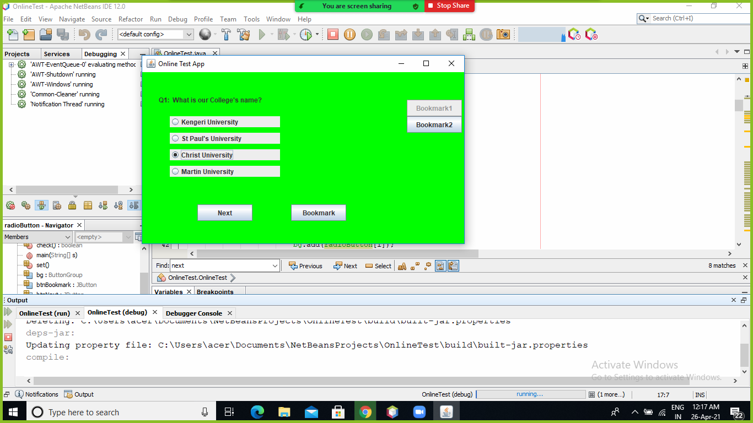

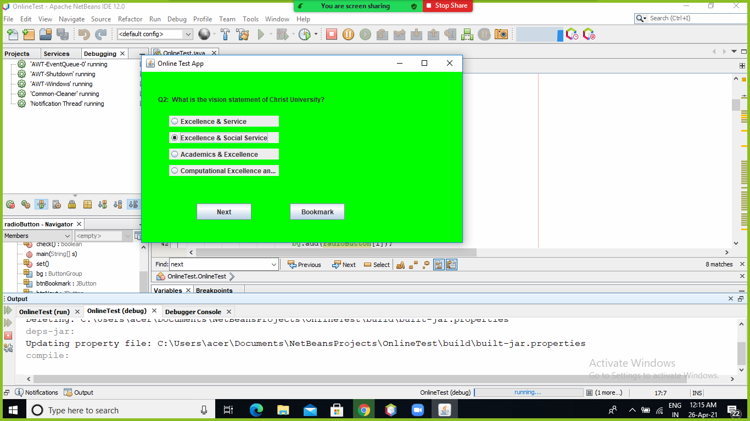

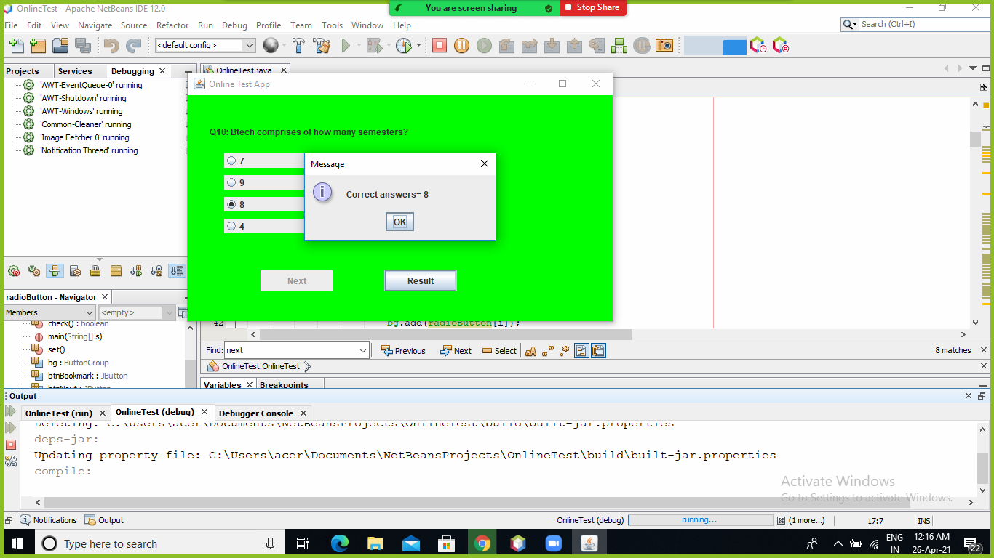

**CONCLUSION**

Online examination system is a user-friendly system, which is very easy and convenient to use. The system is complete in the sense that it is operational and it is tested by entering data and getting the reports in proper order. But there is always a scope for improvement and enhancement.